Viva-2

1 Create any Mountain Range with Snowfall over it using GIMP.

**Steps:**

**Step 1.** Open Image in GIMP.

Use File>Open... command in the top menu or else just press Ctrl+O to open your image.  
The “Open Image” dialog will appear, allowing you to navigate to the file and click on its name.

**Step 2.** Create a New Layer.  
Press the D button to reset the background color to default (black).  
Use Layer> New Layer or press Shift+Ctrl+N to create a new layer.  
Change the snow layer's blend mode to Screen.

Press the D button to reset the foreground color to default (black).  
  
**Step 3**. Apply the RGB Noise Filter to The Snow Effect Layer.

Select the Snow Effect layer on the Layers dialog.  
Use Filters>Noise>RGB Noise to apply the RGB Noise filter.

**Step 4.** Apply the Pixelize Filter to The Snow Effect Layer.

Make sure the Snow Effect layer is selected on the Layers dialog.  
To give the snow crystals effect, we apply the Pixelize filter by choosing Filters> Blur> Pixelize.  
  
**Step 5.** Apply the Motion Blur filter.

Make sure the Snow Effect layer is selected on the Layers dialog.  
Now we'll apply the Motion Blur filter by going to Filters> Blur> Motion Blur...  
The Motion Blur dialog box appears. Here you can set Linear for Blur Type.

**Step 6.** Adjust the Levels.

The last step is to adjust the amount of snow by using Levels.  
Use Color>Level, the Levels dialog box appears.  
Here you can set the Input Levels slider to get your desired snow effect.

**Step 7.** Save Document.  
Use File>Save command in the top menu or else just press Ctrl+S to save your project file.

**OUTPUT:**

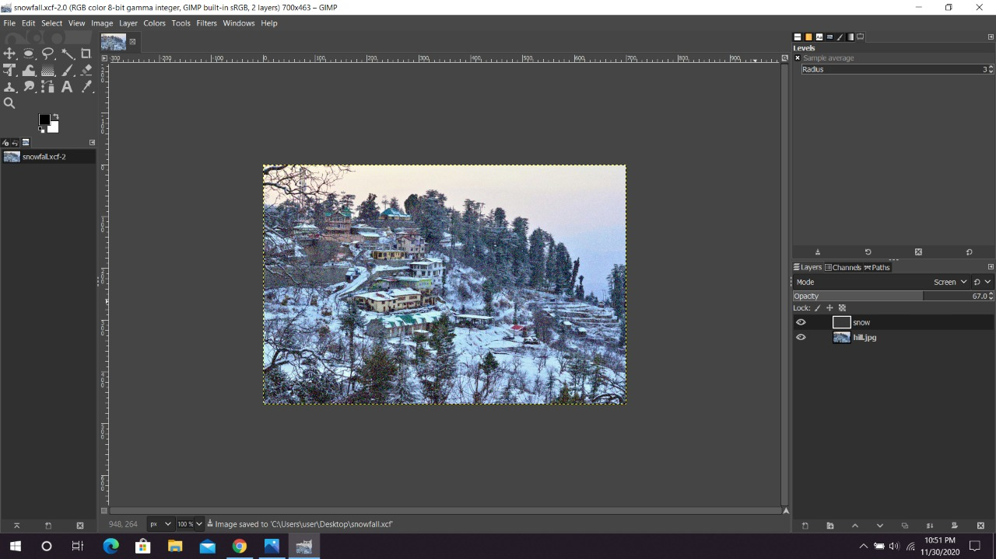

2. Design of Skyscraper using Blender.

**Steps:**

**1** Open Blender, Create a blank file

**2** Add a plane and scale it to an average area of a building, using Shift+A>S.

**3** Switch to edit mode using TAB.

**4** Add some loop cuts using CTRL+R, to create a division of rooms inside the hut. Loop cuts are needed to be added with respect to X and Y axis.

**5** Now delete any one face on any level to bring the plane in L shape and extrude (E) it with respect to the z-axis such that it is equal to the six floors.

**6** To make a dome on the roof, extrude from corner from one of the end of the building block. Add a similar plane in between both floors to differentiate between them.

**7** Now add some pillars to the building by adding a plane first and then by scaling it with respect to z-axis. Now add the same pillar to every corner by just duplicating it. (shift+D)

**8** To create the windows, add a frame apart from the frame for the building. Extrude the window according to how much you depth want. Now duplicate it using (shift+D). Now add an array modifier (x-axis) and increase the number according to the length of the roof. Add a second array modifier (y-axis) and increase the number according to the breadth of roof.

**9** Add the stairs to building by using add-on and then use any of the textures to provide a brick layout for the building.

**10** Now add a camera and a light source to it. And arrange the camera to the best fit view.

**OUTPUT:**

